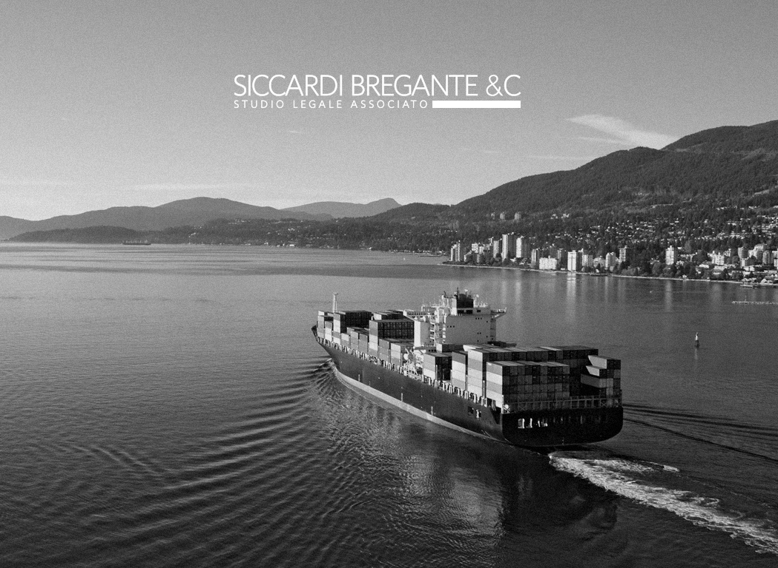
08
Autunno
Angelo Merialdi
This document reproduces the content of statute law provisions and examples of contractual clauses which are referred to in the presentation
Improving the bottom line handout

I - 16121 Genova - Via XX Settembre 37/6
www.siccardibregante.it

1. Introduction

1.1 English Marine Insurance Act 1906

79. Right of subrogation
(1) Where the insurer pays for a total loss, either of the whole, or in the case of goods of any apportionable part, of the subject-matter insured, he thereupon becomes entitled to take over the interest of the assured in whatever may remain of the subject-matter so paid for, and he is thereby subrogated to all the rights and remedies of the assured in and in respect of that subject-matter as from the time of the casualty causing the loss.
310
(2) Subject to the foregoing provisions, where the insurer pays for a partial loss, he acquires no title to the subject-matter insured, or such part of it as may remain, but he is thereupon subrogated to all rights and remedies of the assured in and in respect of the subject-matter insured as from the time of the casualty causing the loss, in so far as the assured has been indemnified, according to this Act, by such payment for the loss.

2. The case of subrogation against shipyards
2.1 Example of a clause in ship conversion whereby the Yard is to be nominated as Insured in addition to Owner
“1. The Owners shall keep the vessel insured during the conversion works, from the time the vessel arrives at the Yard and until she leaves the Yard (ready to resume trading) up to an amount including the pre-conversion insured value (USD [•]) and the cost of conversion works (USD [•]).
2. The above mentioned insurance shall be taken on the terms of the Institute Time Clauses Hulls - Port Risks (20/7/87), supplemented with the Institute Clauses for Builders' Risks (1/6/88) as far as applicable (but excluding collision liability in full and excluding P&l) and shall be in favour of both the Owners and [Yard] as co-assureds, as their respective interest may appear”.

2.2 Waivers of subrogation in the ship conversion / refit / repair contract
Example 1

“Prior to the delivery of the Vessel to the Shipyard, the Client undertakes to procure a waiver of recourse subrogation action from his Insurance against the Shipyard, without any exception or reserve, in respect of any damage and/or loss that may result from the Shipyard, to the Vessel, the Client, the Client’s Personnel (especially the Vessel’s Captain, and the Client’s representatives) as well as any other goods belonging to the Client, in excess of the amount subscribed by the Shipyard’s [liability] insurance accordingly to article 16. This waiver will be ineffective in case of gross negligence or wilful misconduct of the Shipyard”.

Example 2
“During the period in which the Work is being performed and thereafter for the duration of the Guarantee Period, the Owner shall, at its own expense, maintain and keep in force its customary insurance as to hull and machinery and protection and indemnity. The Owner represents and warrants that, under the terms of such policies, coverage does not lapse as a consequence of the Vessel being out of service for the purpose of having the Work performed or with Class suspended due to its status at the time of arriving at the Shipyard and/or entering the dry-dock and that under the policies’ terms Underwriters waive any right of recourse against the Contractor for any liability exceeding the limit set forth in above Article 14.4.1. [i.e. Yard’s limit of liability towards the Owner under the contract]”.

Example 3 (ICOMIA Standard Yacht Refit/Repair Contract - abstract)
“8. LIABILITY AND INSURANCE
8.1 The Owner shall, throughout the Contract Period, and any other period that the Yacht or the Owner's Representative, Captain and crew and any other personnel for whom the Owner is responsible are at the Contractor's Yard or its or its subcontractors' other facilities, maintain hull and machinery and liability insurance in respect of the Yacht and such personnel, all such insurances to be on terms comparable to internationally used policy wordings for yachts of similar type/value and the leading P&l Club rules.
8.2 The aforesaid insurances shall be placed with internationally recognised insurers for no less than the Yacht's market value (in the case of hull and machinery) and the higher of sum in Schedule Ill or any applicable statutory minimum (in the case of liability insurance). Before the Yacht enters the Contractor's Yard or other facilities the Customer shall provide the Contractor with copies of certificates evidencing the aforementioned insurances.
8.3 The Contractor shall maintain Ship Repairer's Liability (SRL) insurance with internationally recognised insurers for no less than the Minimum SRL Insurance and shall make evidence thereof available to the Owner on request. The Owner shall bear the cost of any SRL Premium Contribution, if stipulated herein, as a percentage of the Contract Price and in addition thereto. In case any extension to policy coverage or limits is required by the Owner to offered SRL terms, any additional premium shall be for the account of the Owner.

8.4 Notwithstanding any other provision of this Contract:
8.4.1 the Contractor shall have no contractual liability (as opposed to liabilities insured under the SRL insurance) to the Owner for any amount in excess of the Contractors' Maximum Liability and the Owner for itself, and its assigns, irrevocably waives recourse for any such excess. Where a claim is brought against the Contractor arising out of the same set of facts and based both on contract and tortious or other non-contractual duties or obligations the total aggregate liability of the Contractor shall be the maximum sum which is actually paid by underwriters under the Contractors' SRL insurance”.

2.3 Examples of waivers of subrogation in the insurance contract

Example 1 (fire damage only)
“G) WAIVER OF SUBROGATION FOR FIRE DAMAGES
The Insurers agree to waive their right of subrogation towards the Yard for damages arising from fire during the lay-up and/or during ordinary maintenance only where the S/Y [•] is located”.

Example 2
“CONTRACT ENDORSEMENT
Endorsement effective date: [•]
It is hereby noted and agreed that with effect from Y [•], MY Y [•] will enter to:
[name of the Yard] for approx. 1 month in order to carry out works submitted to the Underwriters.
Underwriters agree to waive their legal rights above the professional liability limit of the yard against [the Yard] or against any controlling company/subsidiary/related company.
Warranted no hot works to be carried out.
All other terms and conditions remain unchanged”.

2.4 Example of “warranty of quality” clause in shipbuilding contract ( based on SAJ Form, Art. IX) – abstract.
- “The Builder, for the period of Twelve (12) months after delivery of the Vessel (hereinafter called “Guarantee Period”), guarantees the Vessel and her engine, including all parts and equipment manufactured, furnished or installed by the Builder under this Contract, and including the machinery, equipment and appurtenances thereof, under the Contract but excluding any item which is supplied or designated by the Buyer or by any other bodies on behalf of the Buyer, against all defects discovered within the Guarantee Period which are due to defective material, faulty construction design, miscalculation and/or poor workmanship or negligent or other improper acts or omissions on the part of the Builder or its subcontractors (hereinafter called the “Defect” or “Defects”) and are not a result of accident, ordinary wear and tear, misuse, mismanagement, negligent or other improper acts or omissions or neglect on the part of the Buyer, its employee or agents …
- The Builder shall have no responsibility or liability for any other defect whatsoever in the Vessel than the Defects specified in Paragraph 1 of this Article. Nor the Builder shall in any circumstance be responsible or liable for any consequential or special loss, damage or expense including but not limited to loss of time, loss of profit of earning or demurrage directly or indirectly occasioned to the Buyer by reason of the Defects specified in Paragraph 1 of this Article or due to repairs or other words done to the Vessel to remedy such Defects.
- The Builder shall be responsible for physical and/or mechanical damages of the Vessel suffered as a consequence of the Builder’s proven defect in the Vessel”.

3. The case of subrogation against classification societies

3.1 United Nations Law of the Sea Convention 1982 (UNCLOS)
“Article 94
Duties of the Flag State
1. Every State effectively exercise its jurisdiction and control administrative, technical and social matters over ships flying its flag.
2. In particular every State shall:
(a) maintain a register of ships containing the name and particulars of ships flying its flag, except those which are excluded from generally accepted international regulations on account of their small size; and
(b) assume jurisdiction under its internal law over ship flying its flag and its master, officers and crew in respect of administrative, technical and social matters concerning the ship.
3. Every State take such measurers for ships flying its flag as necessary to ensure safety at sea with regard, inter alia, to:
(a) the construction, equipment and seaworthiness of ships;
(b) the manning of ships, labour conditions and the training of crews, taking into account the applicable international instruments;
(c) the use of signals, the maintenance of communications and the prevention of collisions.
4. Such measures shall include those necessary to ensure:
(a) that each ship, before registration and thereafter at appropriate intervals, is surveyed by a qualified surveyor of ships, and has on board such charts, nautical publications and navigational equipment and instruments as are appropriate for the safe navigation of the ship”.

3.2 International Convention for the Safety of Life at Sea 1994 as amended (SOLAS) Chapter I – Part B Surveys and Certificates Regulation 6
“Inspection and Survey
The inspection and survey of ships, so far as regards the enforcement of the provisions of the present regulations and the granting of exemptions therefrom, shall be carried out by officers of the Administration. The Administration may, however, entrust the inspections and surveys either to surveyors nominated for the purpose or to organizations recognized by it”.

3.3 SOLAS Chapter II-1 Part A-1 Regulation 3-1
“Structural, mechanical and electrical requirements for ships
In addition to the requirements contained elsewhere in the present regulations, ships shall be designed, constructed and maintained in compliance with the structural, mechanical and electrical requirements of a classification society which is recognized by the Administration in accordance with the provisions of regulation XI-1/1, or with applicable national standards of the Administration which provide an equivalent level of safety”.

3.4 IMO CODE FOR RECOGNIZED ORGANIZATIONS (RO CODE)
“Statutory certification and services means certificates issued, and services provided, on the authority of laws, rules and regulations set down by the Government of a sovereign State. This includes plan review, survey, and/or audit leading to the issuance of, or in support of the issuance of, a certificate by or on behalf of a flag State as evidence of compliance with requirements contained in an international convention or national legislation. This includes certificates issued by an organization recognized by the flag State in accordance with the provisions of SOLAS regulation XI-1/1, and which may incorporate demonstrated compliance with the structural, mechanical and electrical requirements of the RO under the terms of its agreement of recognition with the flag State”.

3.5 Abstract from BV general conditions: clause delimiting the responsibility of the classification society – no warranty of seaworthiness
“ARTICLE 5
5.1. - The Society acts as a provider of services. This cannot be construed as an obligation bearing on the Society to obtain a result or as a warranty.
5.2. - The certificates issued by the Society pursuant to 5.1. here above are a statement on the level of compliance of the Unit to its Rules or to the documents of reference for the Services provided for. In particular, the Society does not engage in any work relating to the design, building, production or repair checks, neither in the operation of the Units or in their trade, neither in any advisory services, and cannot be held liable on those accounts. Its certificates cannot be construed as an implied or express warranty of safety, fitness for the purpose, seaworthiness of the Unit or of its value for sale, insurance or chartering.
5.3. - The Society does not declare the acceptance or commissioning of a Unit, nor of its construction in conformity with its design, that being the exclusive responsibility of its owner or builder.
5.4. - The Services of the Society cannot create any obligation bearing on the Society or constitute any warranty of proper operation, beyond any representation set forth in the Rules, of any Unit, equipment or machinery, computer software of any sort or other comparable concepts that has been subject to any survey by the Society.

3.6 Abstract from BV general conditions: clause containing limitations of the liability of the classification society
“ARTICLE 6
6.1. - The Society accepts no responsibility for the use of information related to its Services which was not provided for the purpose by the Society or with its assistance.
6.2. - If the Services of the Society or their omission cause to the Client a damage which is proved to be the direct and reasonably foreseeable consequence of an error or omission of the Society, its liability towards the Client is limited to ten times the amount of fee paid for the Service having caused the damage, provided however that this limit shall be subject to a minimum of eight thou-sand (8,000) Euro, and to a maximum which is the greater of eight hundred thousand (800,000)Euro and one and a half times the above mentioned fee. These limits apply regardless of fault including breach of contract, breach of warranty, tort, strict liability, breach of statute, etc. The Society bears no liability for indirect or consequential loss whether arising naturally or not as a consequence of the Services or their omission such as loss of revenue, loss of profit, loss of production, loss relative to other contracts and indemnities for termination of other agreements.
6.3. - All claims are to be presented to the Society in writing within three months of the date when the Services were supplied or (if later) the date when the events which are relied on of were first known to the Client, and any claim which is not so presented shall be deemed waived and absolutely barred. Time is to be interrupted thereafter with the same periodicity”.

